**Computer Communication Networks**

2021/Spring – Midterm Exam

1

A reliable data link protocol can recover from errors affecting transmissions on individual links. However, there are more sources of losses in an interconnection network formed by multiple routers. For instance, messages can be dropped by a router whose buffer is completely filled with packets. Moreover, a router may malfunction or break, thus destroying all buffered messages. Thus, it makes more sense to use a transport protocol for reliable data delivery in the considered scenario.

2

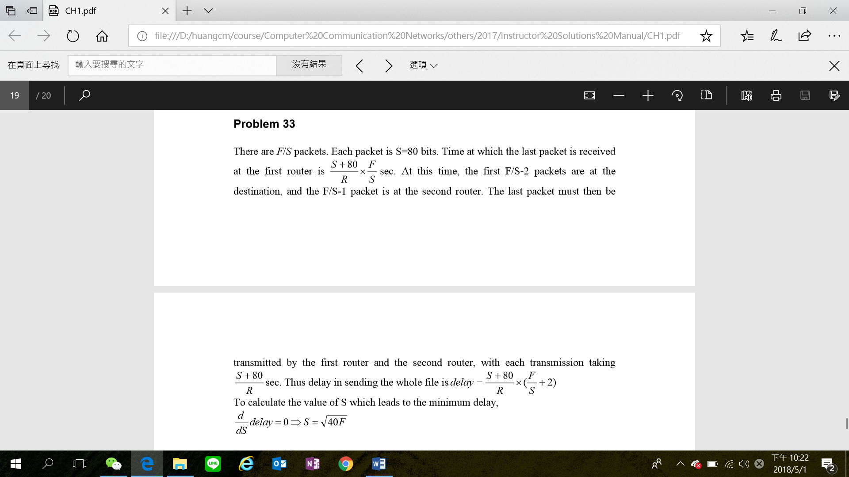

3

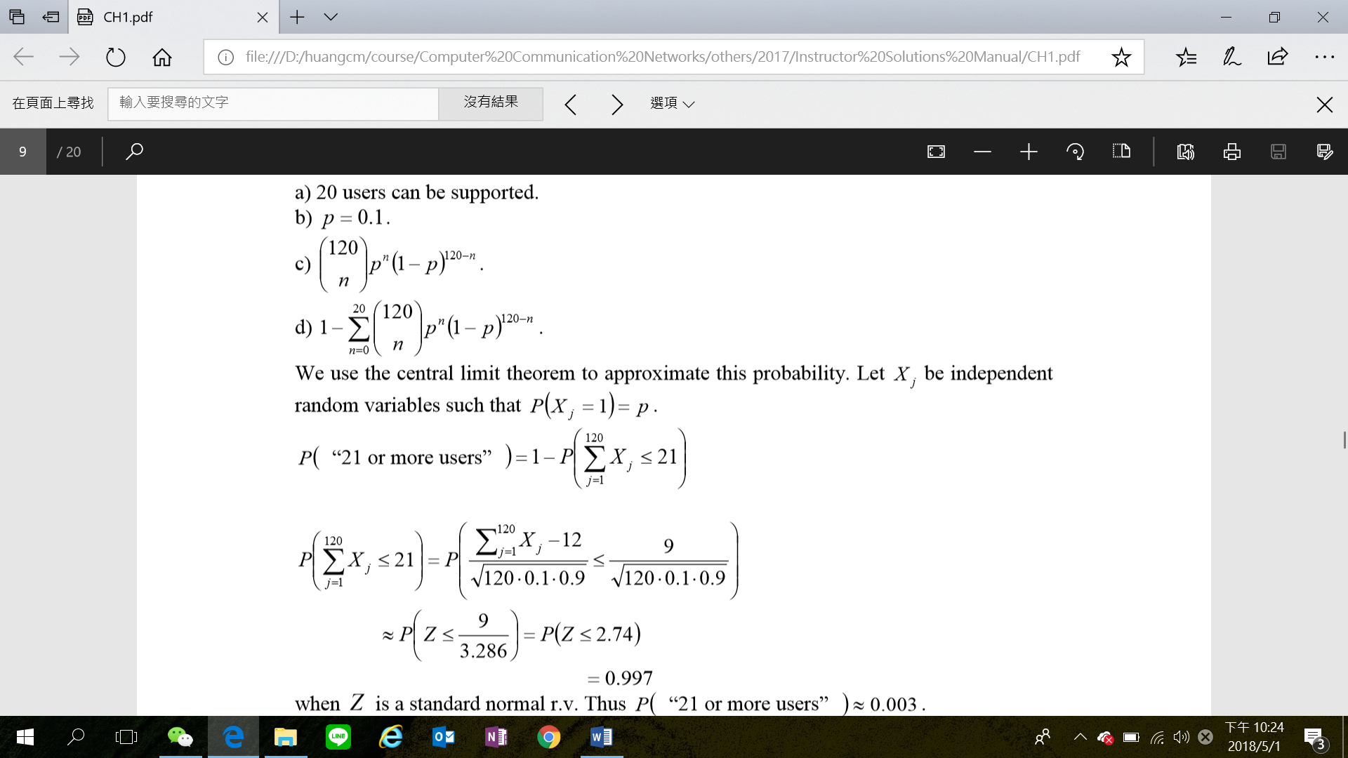

4

1. Recall that in BitTorrent, a peer picks a random peer and optimistically unchokes the peer for a short period of time. Therefore, Alice will eventually be optimistically unchoked by one of her neighbors, during which time she will receive chunks from that neighbor.
2. For the TCP application, as soon as the client is executed, it attempts to initiate a TCP connection with the server. If the TCP server is not running, then the client will fail to make a connection. For the UDP application, the client does not initiate connections (or attempt to communicate with the UDP server) immediately upon execution

5

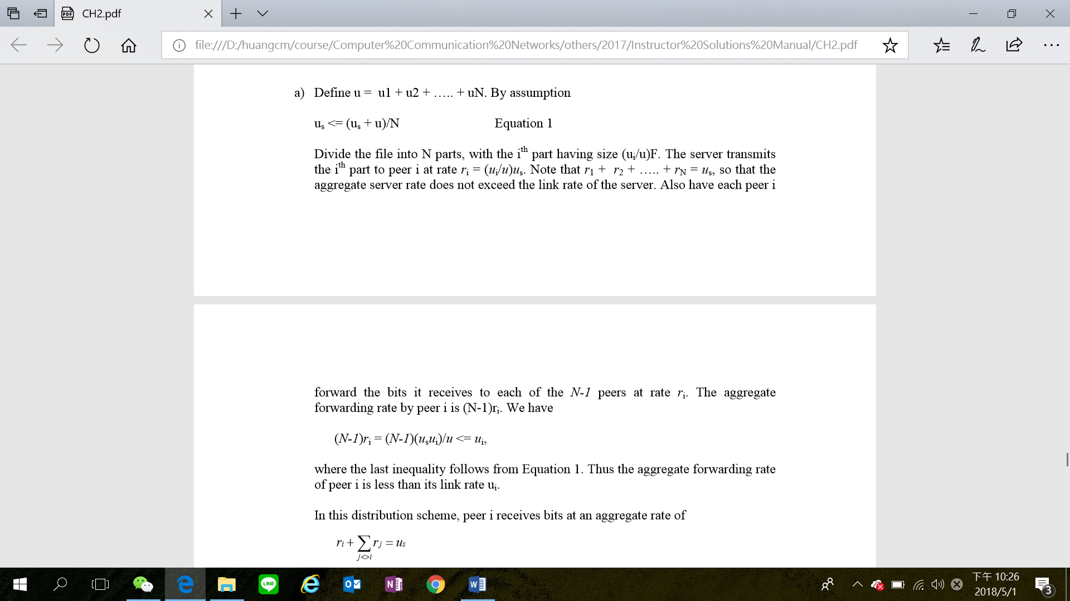

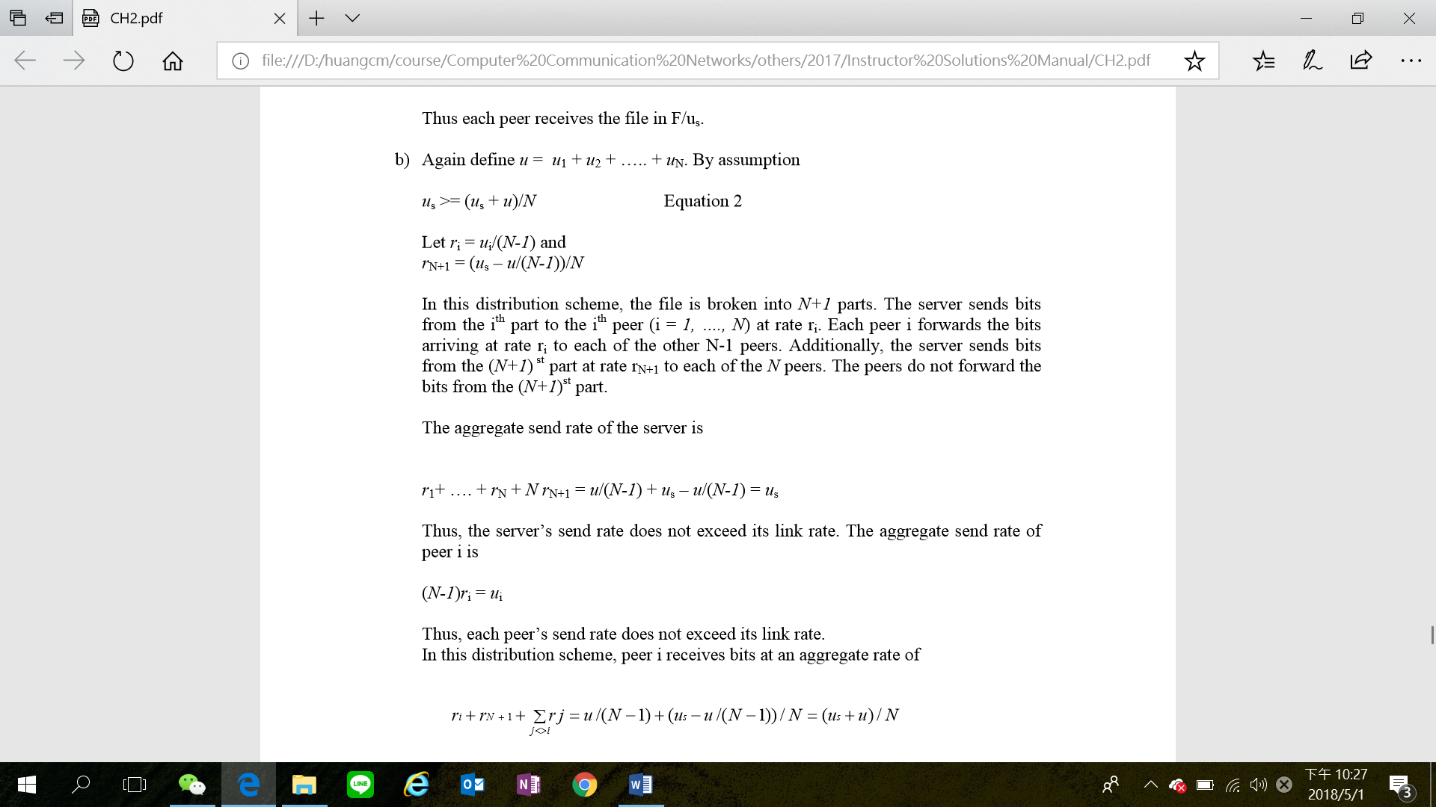

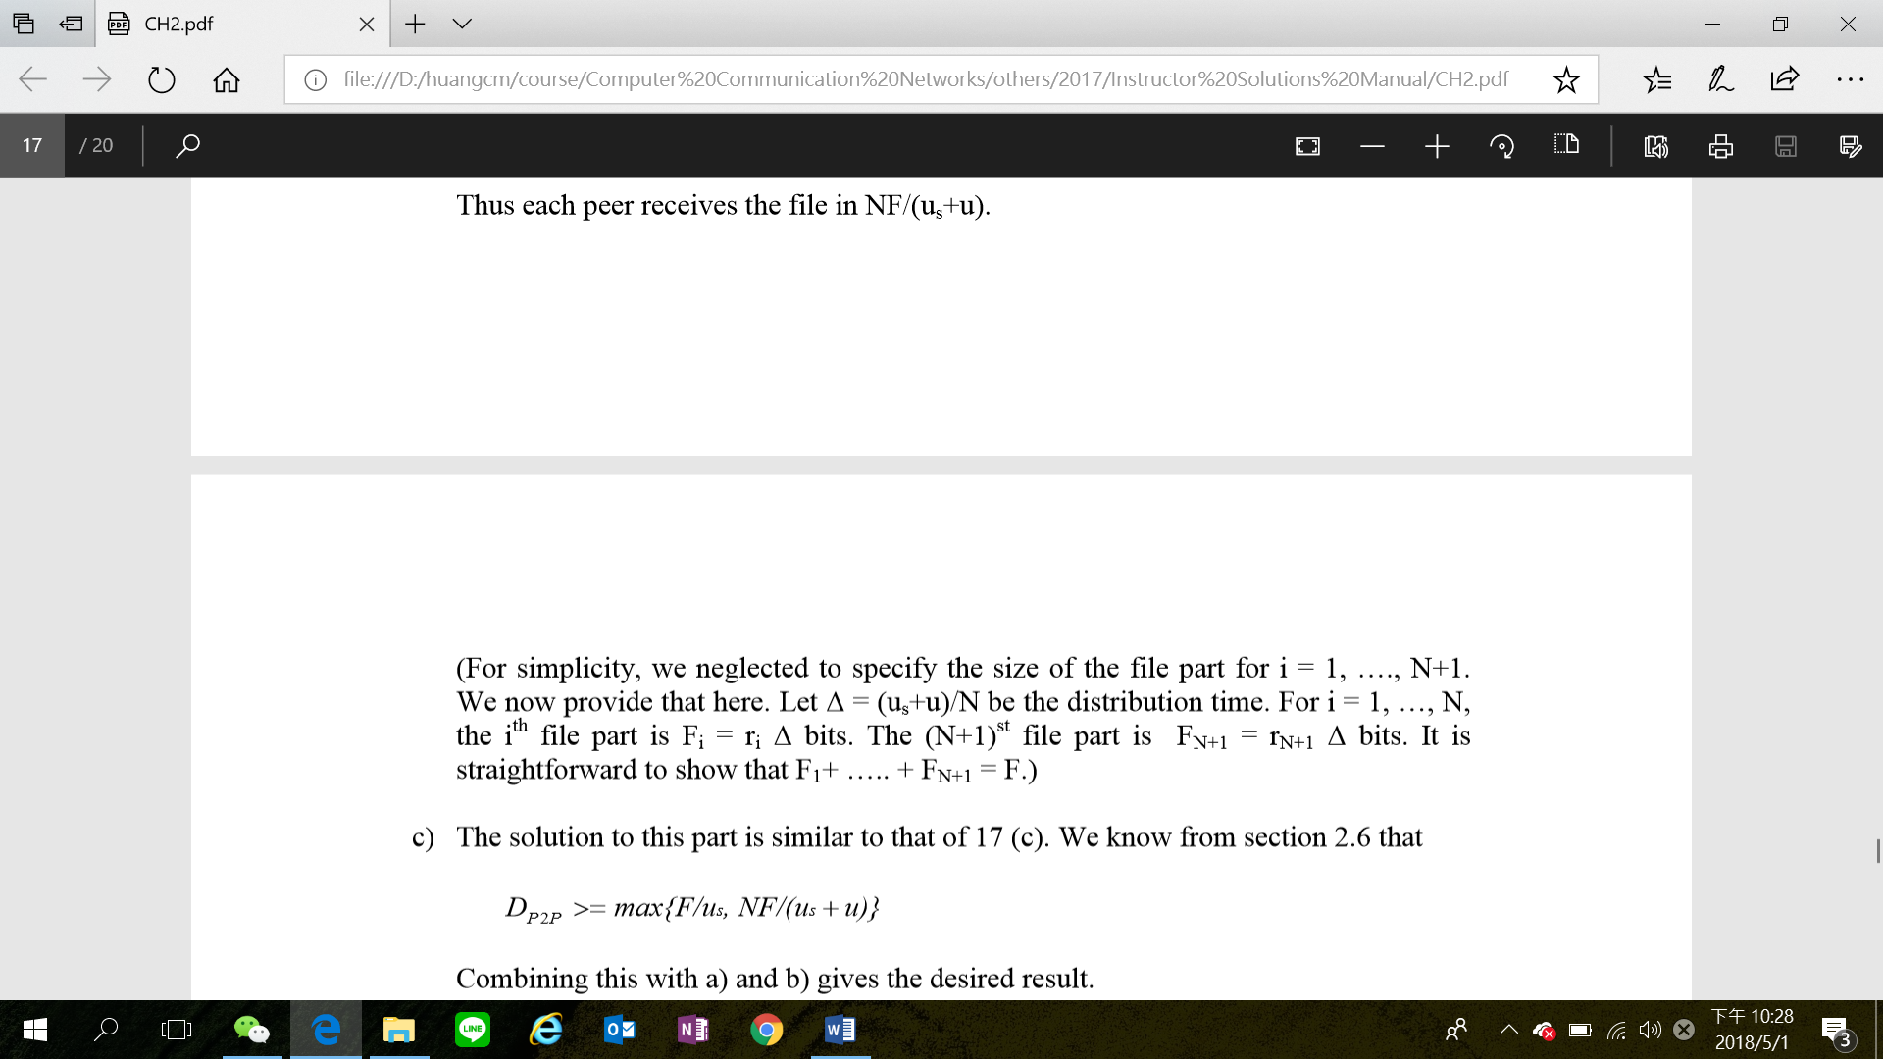

6

1. N
2. 2N

7

1. A UDP socket is fully identified by the destination IP address and the destination port. A TCP socket, instead, is fully identified by the source IP address, the source port, the destination address, and the destination port. This happens as TCP establishes a bi-directional full-duplex session between the sender and the receiver.
2. Yes. The application developer can put reliable data transfer into the application layer protocol. This would require a significant amount of work and debugging, however.

8

No, the receiver cannot be absolutely certain that no bit errors have occurred. This is because of the manner in which the checksum for the packet is calculated. If the corresponding bits (that would be added together) of two 16-bit words in the packet were 0 and 1 then even if these get flipped to 1 and 0 respectively, the sum still remains the same. Hence, the 1s complement the receiver calculates will also be the same. This means the checksum will verify even if there was transmission error.

9

a) Here we have a window size of N=3. Suppose the receiver has received packet k-1, and has ACKed that and all other preceding packets. If all of these ACK's have been received by sender, then sender's window is **[k, k+N-1]**. Suppose next that none of the ACKs have been received at the sender. In this second case, the sender's window contains k-1 and the N packets up to and including k-1. The sender's window is thus **[k-N,k-1]**. By these arguments, the senders window is of size 3 and begins somewhere in the range [k-N,k].

b) If the receiver is waiting for packet k, then it has received (and ACKed) packet k-1 and the N-1 packets before that. If none of those N ACKs have been yet received by the sender, then ACK messages with values of [k-N,k-1] may still be propagating back.Because the sender has sent packets [k-N, k-1], it must be the case that the sender has already received an ACK for k-N-1. Once the receiver has sent an ACK for k-N-1 it will never send an ACK that is less that k-N-1. Thus the range of inflight ACK values can range from **k-N-1 to k-1**.

10)

